# -JOINS Continued

## **USE – SQL Database 3**

## **OUTER JOIN**

SELECT FullName, Extension

FROM

Personnel INNER JOIN PersonnelPhone

ON Personnel.PersID = PersonnelPhone.PersID

ORDER BY FullName ASC, Extension ASC;

This is an inner join – what does it do? Screen Shot your results

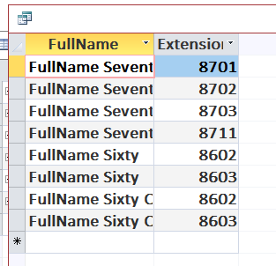

What happens if they have no phone number?

If there is no phone number then we won’t be able to join Personnel with PersonnelPhone, hence we won’t get any result.

SELECT FullName, Extension

FROM

Personnel LEFT JOIN PersonnelPhone

ON Personnel.PersID = PersonnelPhone.PersID

ORDER BY FullName ASC, Extension ASC;

Besides using the LEFT JOIN clause – what does this clause show that the inner join does not? Screen shot your results

For inner join it shows:

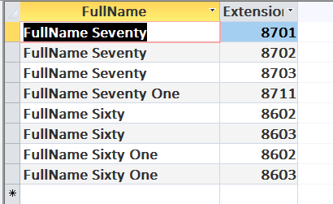

Whereas for Left Join it shows

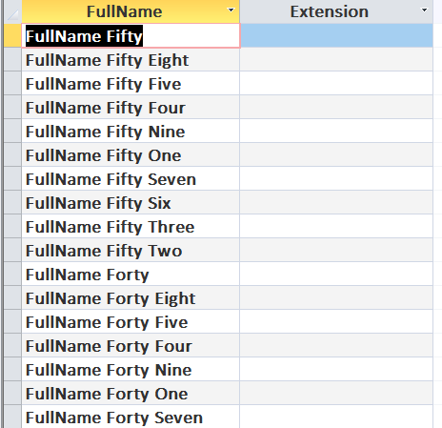

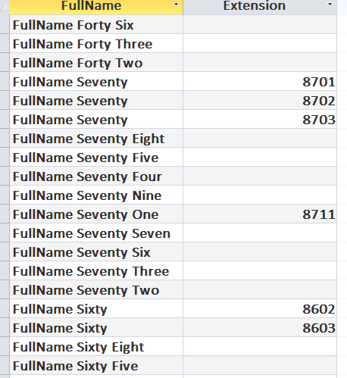

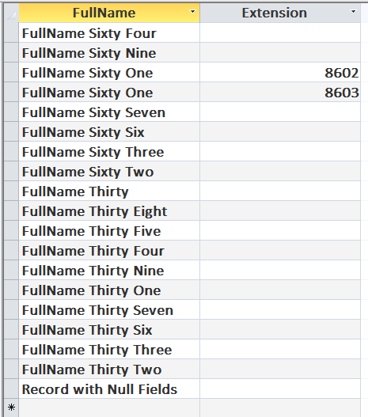

SELECT FullName, PersonnelPhone.Extension, DeviceType

FROM

(Personnel LEFT JOIN PersonnelPhone

ON Personnel.PersID = PersonnelPhone.PersID)

LEFT JOIN Phone

ON PersonnelPhone.Extension = Phone.Extension

ORDER BY FullName ASC, PersonnelPhone.Extension ASC;

What does this statement show that the other two do not? Screen shot results

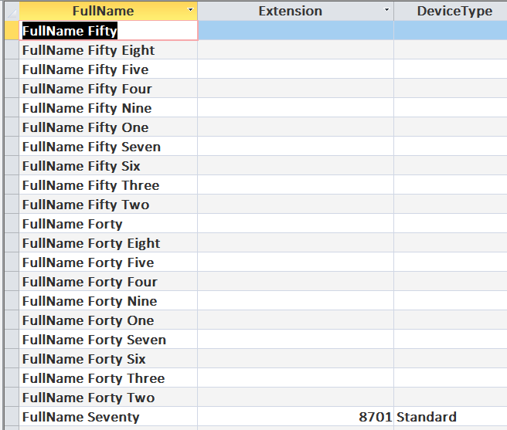

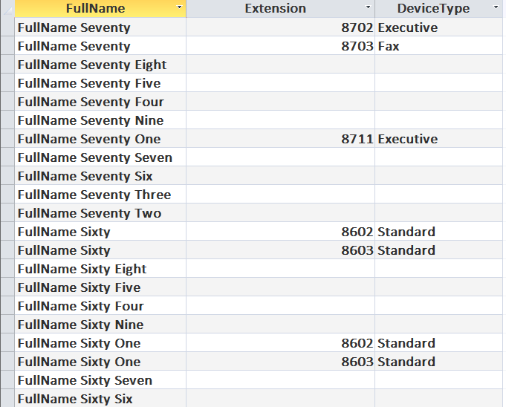 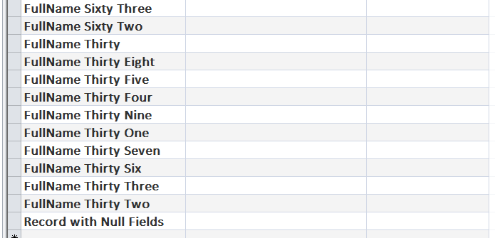

## **NESTING of OUTER JOINS**

SELECT FullName, PersonnelPhone.Extension, DeviceType

FROM

(Personnel LEFT JOIN PersonnelPhone

ON Personnel.PersID = PersonnelPhone.PersID)

LEFT JOIN Phone

ON PersonnelPhone.Extension = Phone.Extension

ORDER BY FullName ASC, PersonnelPhone.Extension ASC;

Screen shot results:

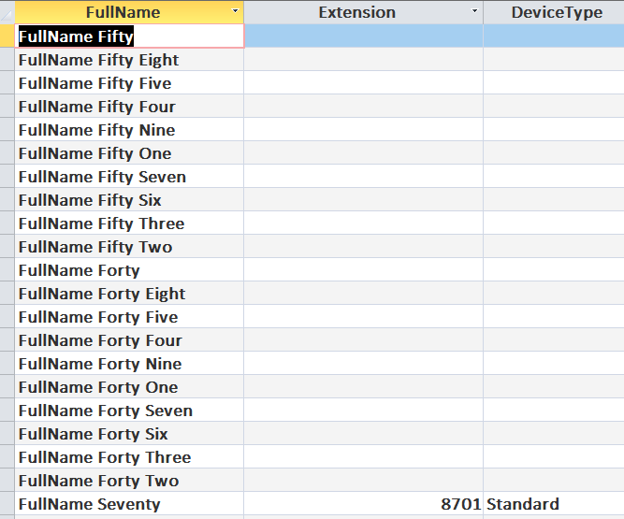 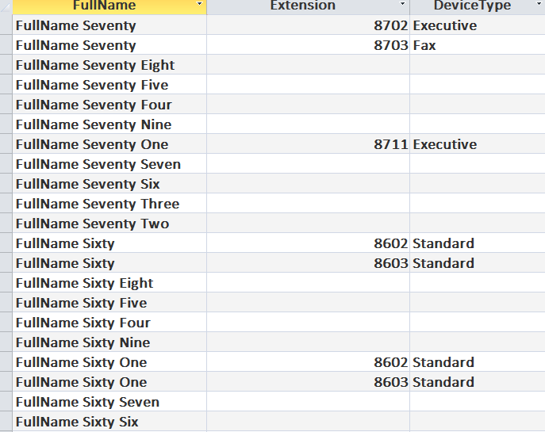 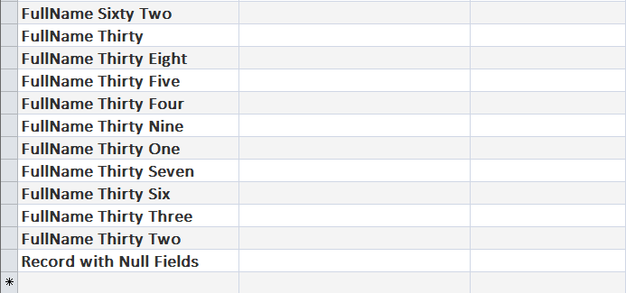

What happens if you replace the first LEFT JOIN in the above statement with an INNER JOIN? – Screen shot results

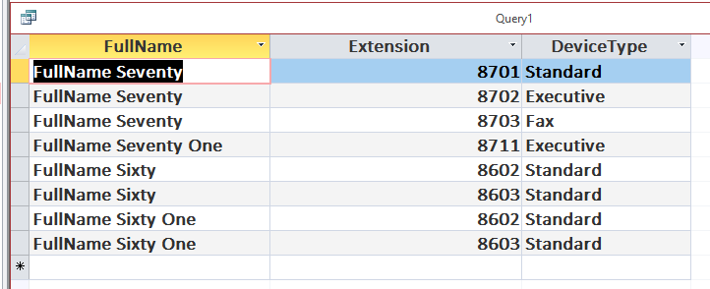

What happens if you replace the second LEFT JOIN in the above statement (leaving the first LEFT JOIN as is) with an INNER JOIN? – Screen shot results



## **USE – SQL Database 4**

## **UNIONS**

SELECT Dept

FROM Dept

WHERE Dept Like "%S%"

UNION

SELECT Dept

FROM Personnel

GROUP BY Dept

HAVING Count(*) > 7

ORDER BY Dept ASC;

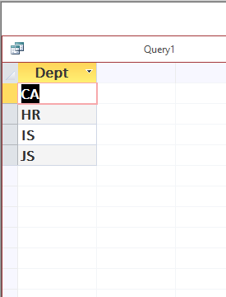

Screen Shot your results

